# Blind 75

217. Contains Duplicate

LC 242. Valid Anagram

LC 1. Two Sum

LC 49. Group Anagrams

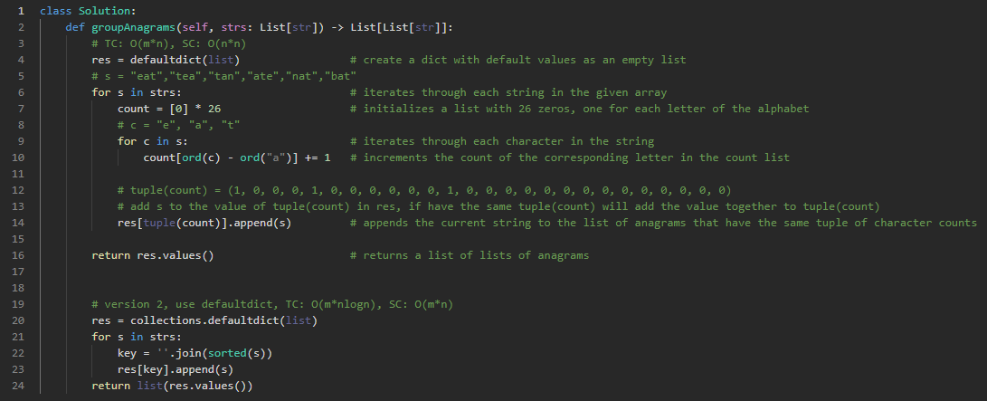

347. Top K Frequent Elements

LC 238. Product of Array Except Self

LintCode: 659 · Encode and Decode Strings

128. Longest Consecutive Sequence

LC 125. Valid Palindrome

LC 15. 3Sum

LC 11. Container With Most Water

LC 121. Best Time to Buy and Sell Stock

LC 3. Longest Substring Without Repeating Characters

LC 424. Longest Repeating Character Replacement

LC 20. Valid Parentheses

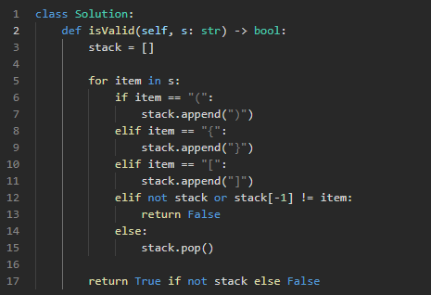

LC 153. Find Minimum in Rotated Sorted Array

LC 33. Search in Rotated Sorted Array

LC 206. Reverse Linked List

LC 21. Merge Two Sorted Lists

LC 143. Reorder List

LC 19. Remove Nth Node From End of List

LC 141. Linked List Cycle

LC 23. Merge k Sorted Lists

LC 226. Invert Binary Tree

LC 104. Maximum Depth of Binary Tree

LC 100. Same Tree

LC 572. Subtree of Another Tree

LC 235. Lowest Common Ancestor of a Binary Search Tree

LC 102. Binary Tree Level Order Traversal

LC 98. Validate Binary Search Tree

LC 105. Construct Binary Tree from Preorder and Inorder Traversal

LC 230. Kth Smallest Element in a BST

LC 124. Binary Tree Maximum Path Sum

LC 297. Serialize and Deserialize Binary Tree

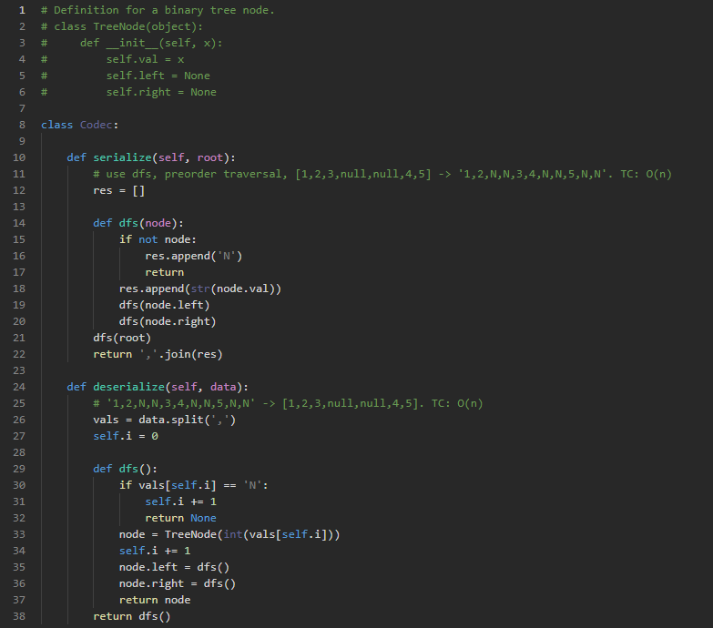

LC 208. Implement Trie (Prefix Tree)

LC 211. Design Add and Search Words Data Structure

LC 212. Word Search II

LC 295. Find Median from Data Stream

LC 39. Combination Sum

LC 79. Word Search

LC 200. Number of Islands

LC 133. Clone Graph

LC 417. Pacific Atlantic Water Flow

LC 207. Course Schedule

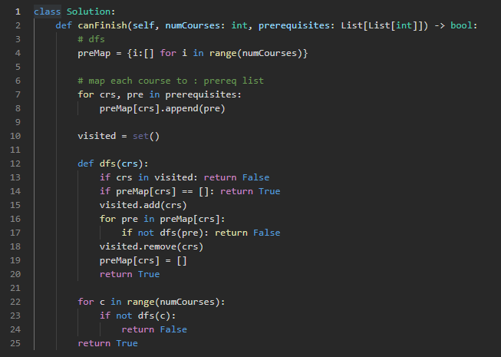

Lintcode: 591 · Connecting Graph III

Lintcode: 178 · Graph Valid Tree

Lintcode 892 · Alien Dictionary

LC 70. Climbing Stairs

LC 198. House Robber

LC 213. House Robber II

LC 647. Palindromic Substrings

LC 5. Longest Palindromic Substring

LC 647. Palindromic Substrings

LC 322. Coin Change

LC 152. Maximum Product Subarray

LC 139. Word Break

LC 300. Longest Increasing Subsequence

LC 62. Unique Paths

LC 1143. Longest Common Subsequence

LC 53. Maximum Subarray

LC 55. Jump Game

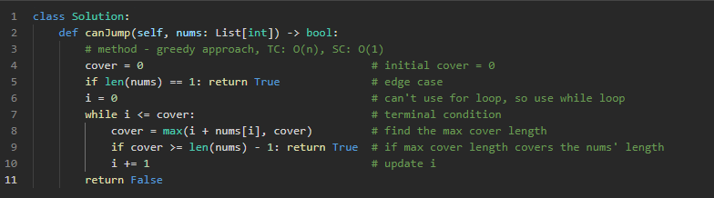

LC 57. Insert Interval

LC 56. Merge Intervals

LC 435. Non-overlapping Intervals

LintCode 920 · Meeting Rooms

**LintCode 919 · Meeting Rooms II**

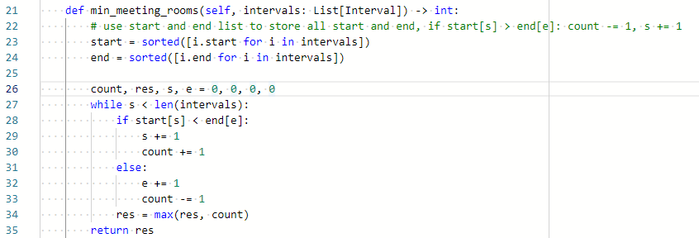

LC 48. Rotate Image

LC 54. Spiral Matrix

LC 73. Set Matrix Zeroes

LC 76. Minimum Window Substring

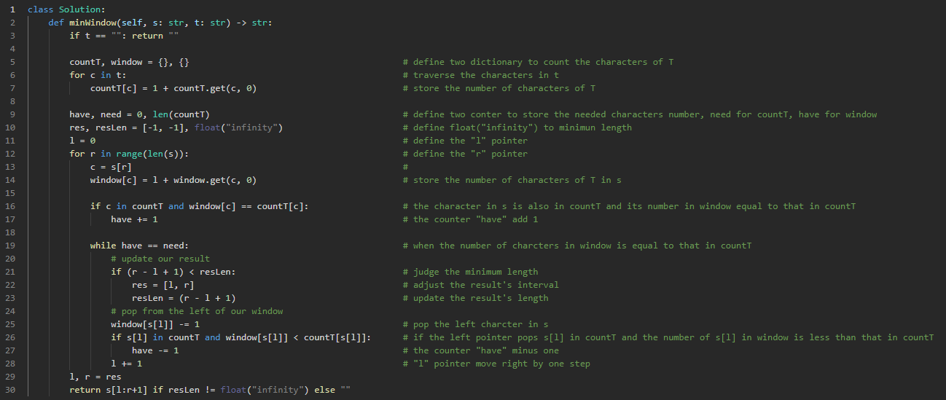

LC 191. Number of 1 Bits

LC 338. Counting Bits

LC 190. Reverse Bits

LC 268. Missing Number

LC 371. Sum of Two Integers

